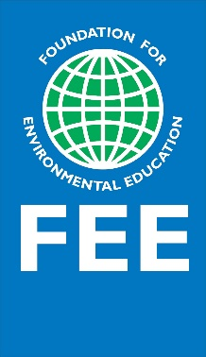

STORIES OF CHANGE
Best Practice Template for Schools and Youth Clubs
#litterlessplus

Please fill-in this template to the best of your knowledge and provide us with an example of a youth-led project aiming fulfil one or more of the following objectives:
  - Reduce litter and waste
  - Promote responsible production and consumption
  - Increase knowledge and take actions to reduce invisible pollutants
  - Promote the circular economy model
By submitting this story, you consent that you have permission to share the information and digital content presented. The information may be shared on Foundation for Environmental Education’s global communication channels.
We thank you in advance for your participation and will do our best to share it with our network.
- Foundation for Environmental Education

- ABOUT THE SCHOOL/YOUTH CLUB

Country
Name of school or youth club
Name of contributor
Email of contributor
Programmes involved in (ES/LEAF/YRE/other programmes)
If other, please indicate which
Schools: Level of education (pre-primary/primary/secondary/tertiary)
Social and geographical context of the school. Please describe where is the school situated, and what are the underlying social conditions of the students and their families.

- RELATIONSHIP WITH FEE PROGRAMMES

Has your school or youth club ever received an Eco-Schools Green Flag/LEAF award/YRE award? If so, which award and which year?

- THE PROJECT

Title of the project
What were the educational and environmental objectives of the project?
Description of the activities carried out in the project.
What resources (financial and not financial. e.g., human resources, items, etc.) were needed to complete the activity/project?
How does the project promote the SDGs? Which out of the 17 SDGs does it touch upon?

- IMPACT/LEARNING

Outcomes: Please mention any new skills developed, knowledge gained, behaviours, experiences, and the impact you observed on youth, students, teachers, or the community because of the project.
Outputs: Please list all measurable figures related to the objectives of the project, e.g., change in literacy, products and materials avoided/re-used/refurbished, waste streams minimised/recycled, etc.
If you had to do this activity again, what would you do differently?
Please give a quote or personal story by one or more participants. Indicate the name and capacity of the person giving the quote and ensure you have permission to share.

- OUTREACH

No. of teachers/youth guides involved
No. of youth/students involved
Participants age groups
Apart from the above-mentioned participants, who else participated directly or indirectly in the project activities, e.g., the community / parents / municipality / governmental office? What was their role?
Was the activity disseminated in any way? If so, how? Please share the links to any published material (e.g., videos, newsletters, websites, news outlets, etc.)

Please send 4-5 high quality images that describe the activities. Before sharing the images, please ensure that you have the copyrights *Supported image types: .jpg .gif .png

